DTSC 671: AI Solutions in the Cloud
Curtis Nielson

RAG with Amazon Bedrock Knowledge Bases

Submission
- (10 pts) Introduction (introduce the topic that connects all the source documents)

I have been employed by 3M Health Information Systems (HIS) for several years. Originally a division within 3M's Health Care Business Group, HIS became part of Solventum when 3M spun off its various healthcare divisions into an independent business in April 2024. A few weeks ago, Solventum announced its intent to separate the HIS division through a strategic sale or an independent spin-off.

The documents collected for this project focus on this proposed separation. They include public SEC filings, official corporate announcements, and published opinion pieces. These materials present arguments both for and against the separation, reflecting the analysis of industry experts, thought leaders, and other key stakeholders.

- (10 pts) Brief Description of each source document with citation or web address

Below are the references used. Many are investor announcements and required SEC filing reports that provide financial and corporate structure updates. These documents identify Solventum Corporation as the author. The remaining documents are from financial institutions, financially focused media outlets, and large investor organizations that have prominent opinions on the subject.

References
Earnings Anatomy. (2026, March 6). Solventum (SOLV) 2025 10-K: Analyzing the 3M spin-off and debt paydown. Earnings Anatomy. Retrieved September 13, 2026, from https://earningsanatomy.com/blogs/solventum-solv-2025-10k-analysis-3m-spinoff

Solventum Corporation. (2024, February 20). Registration statement on Form 10 and information statement. U.S. Securities and Exchange Commission. Retrieved September 13, 2026, from https://filecache.investorroom.com/mr5ir_3mspinco/153/Solventum_Form_10.pdf

Solventum Corporation. (2025, March 20). Investor Day transcript. Solventum Investor Relations. Retrieved September 13, 2026, from https://investors.solventum.com/_assets/_126b32dd547e00c41e5837743bc3789f/solventum/db/3711/35149/file/SOLV_2025%2BInvestor%2BDay%2BTranscript%2B-%2BvF.pdf

Solventum Corporation. (2026). Annual report (Form 10-K) for fiscal year 2025. U.S. Securities and Exchange Commission. Retrieved September 13, 2026, from https://investors.solventum.com/financials/sec-filings

Solventum Corporation. (2026, August 5). Q2 2026 shareholder letter. Solventum Investor Relations. Retrieved September 13, 2026, from https://investors.solventum.com/news-events/events-presentations/detail/20260805-q2-2026-earnings

Solventum Corporation. (2026, August 5). Q2 FY26 earnings call transcript. Solventum Investor Relations. Retrieved September 13, 2026, from https://investors.solventum.com/_assets/_e78219b3b8d85afd378d4f5177fcf8a7/solventum/db/3734/35343/webcast_transcript/SOLV_2Q26+Earnings+Transcript_08052026_vF.pdf

Solventum Corporation. (2026, August 5). Quarterly report (Form 10-Q) for the quarter ended June 30, 2026. U.S. Securities and Exchange Commission. Retrieved September 13, 2026, from https://investors.solventum.com/financials/sec-filings

Squire, K. (2024, July 27). Activist Trian has a few levers to pull to build shareholder value at Solventum. CNBC. Retrieved September 13, 2026, from https://www.cnbc.com/2024/07/27/activist-trian-has-a-few-levers-to-pull-to-build-shareholder-value-at-solventum.html

Trian Fund Management, L.P. (2025, January 8). Trian issues open letter to Solventum shareholders. Retrieved September 13, 2026, from https://trianpartners.com/wp-content/uploads/2025/01/2025-01-08-SOLV-Shareholder-Letter-Release.pdf

Trian Fund Management, L.P. (2026, April 30). Trian calls on Solventum's board to create value: Publishes open letter and slide deck. Retrieved September 13, 2026, from https://trianpartners.com/wp-content/uploads/2026/04/Trian-Calls-on-Solventums-Board-to-Create-Value_-Publishes-Open-Letter-and-Slide-Deck-Combined-Wrap-Letter-Slides.pdf

  - (30 pts) Prompt and Responses
    - Your prompt to RAG system
What are the top 3 arguments for and against separating HIS from Solventum?

    - Copy-pasted RAG response

Top 3 Arguments FOR Separating HIS from Solventum:
- Strategic Fit & Value Creation: HIS is considered non-core to Solventum's primary MedSurg business. It is believed that HIS can create greater value outside of Solventum, either as an independent company or combined with a scaled player in the software space, particularly given the rapidly changing AI landscape.
- Focus & Resource Allocation: Separating HIS would make Solventum a more dedicated MedTech company, sharpening focus on MedSurg and Dental. Keeping different businesses together creates conflict in allocating resources across units with different priorities, investment cycles, and operational needs. Software businesses require rapid development cycles and agile AI integration, while medical hardware requires sustained capital for physical R&D.
- Unlocking Shareholder Value: The separation is expected to unlock shareholder value by allowing each business to operate with dedicated management teams, better-aligned incentives, and the capital flexibility needed to pursue their respective growth strategies. HIS, as a standalone entity, could target a $10 billion global addressable market and accelerate its AI-driven capabilities. ^{[1]} ^{[2]} ^{[3]}
Top 3 Arguments AGAINST Separating HIS from Solventum:
- Execution Complexity & Timing Risk: While HIS is described as relatively easier to separate due to its lack of a manufacturing footprint, no separation is truly simple. The transaction is expected to take 12 to 18 months to close, and the separation process will introduce financial variability and uncertainty for Solventum in the near term.
- Uncertainty of Separation Method & Value: It is still unclear whether the separation will be a spin-off, sale, or merger, and it is described as too early to provide financial details. This uncertainty around the method and use of proceeds makes it difficult to guarantee that maximum shareholder value will actually be achieved.
- Loss of a Differentiated, High-Value Asset: HIS generates $1.4 billion in annual revenue, is embedded in over 75% of U.S. hospitals, and processes approximately 660 million clinical documents per month. Separating such a resilient and deeply embedded business means Solventum gives up a significant revenue stream and a uniquely advantaged software platform that few MedTech investors fully appreciate. ^{[4]} ^{[5]} ^{[6]} ^{[7]}

    - Copy-pasted LLM response
Google Gemini was used.
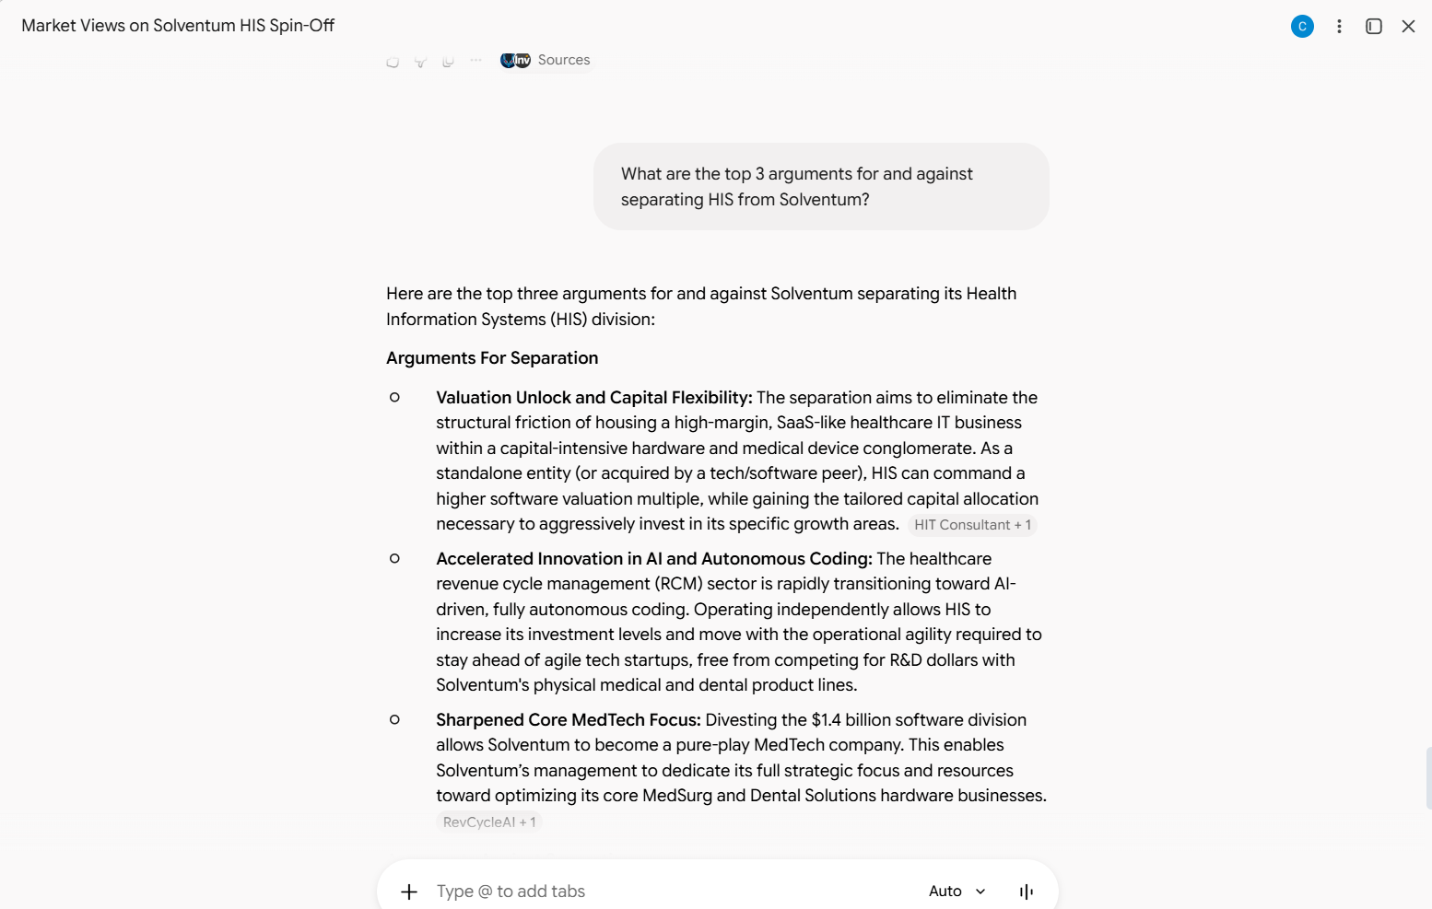
Here are the top three arguments for and against Solventum separating its Health Information Systems (HIS) division:
Arguments For Separation
- Valuation Unlock and Capital Flexibility: The separation aims to eliminate the structural friction of housing a high-margin, SaaS-like healthcare IT business within a capital-intensive hardware and medical device conglomerate. As a standalone entity (or acquired by a tech/software peer), HIS can command a higher software valuation multiple, while gaining the tailored capital allocation necessary to aggressively invest in its specific growth areas. HIT Consultant+ 1
- Accelerated Innovation in AI and Autonomous Coding: The healthcare revenue cycle management (RCM) sector is rapidly transitioning toward AI-driven, fully autonomous coding. Operating independently allows HIS to increase its investment levels and move with the operational agility required to stay ahead of agile tech startups, free from competing for R&D dollars with Solventum's physical medical and dental product lines.
- Sharpened Core MedTech Focus: Divesting the $1.4 billion software division allows Solventum to become a pure-play MedTech company. This enables Solventum’s management to dedicate its full strategic focus and resources toward optimizing its core MedSurg and Dental Solutions hardware businesses. RevCycleAI+ 1
Arguments Against Separation
- Operational Distraction and "Separation Hangover": Solventum only recently completed a massive, complex spin-off from 3M in April 2024. Executing another structural separation of a massive global division—estimated to take 12 to 18 months—risks severe organizational fatigue, management distraction, and heavy legal, banking, and technology transition costs. MedTech Dive
- Customer Disruption and Integration Risks: HIS technology is deeply embedded in over 75% of U.S. hospitals, often tied to multi-year contracts and tightly integrated with major EHR systems like Epic and Oracle. A change in ownership creates uncertainty regarding product roadmaps, contract continuity, and software updates. If acquired by private equity, hospitals fear a shift toward aggressive price escalation and slower product support. RevCycleAI+ 2
- Loss of Revenue Diversification and High-Margin Scale: HIS accounts for approximately 16% of Solventum's total sales and boasts a highly profitable, recurring revenue model. Divesting this sticky software business removes a significant growth engine, leaving Solventum highly dependent on its MedSurg and Dental divisions, which have experienced relatively stagnant growth in recent years. MedTech Dive+ 1

  - (15 pts) Similarities (at least 2 similarities between the RAG & LLM response)
    - Both the RAG and LLM responses included Solventum’s management reasoning that the move is “designed to unlock shareholder value.” This was expected from the RAG because unlocking shareholder value is a repeated theme in documents published by Solventum. It was not expected to be so prominent in the LLM response, but this may suggest that Solventum’s communication efforts have been successful in presenting its viewpoint across many different sources.
    - Both the RAG and LLM responses identify that a separation would enable Solventum to sharpen its focus as a MedTech company, though they assign it different priorities.
    - Both RAG and LLM responses note that HIS generates $1.4 billion in revenue.

  - (15 pts) Differences (at least 3 differences between the RAG & LLM response)

    - The LLM response referenced Solventum’s separation from 3M, which occurred recently but was not a focus of the dataset the RAG used. The LLM pointed out that separation fatigue is an argument against separation, but the RAG did not consider it a top-three argument.
    - While both the RAG and LLM responses mention that HIS generates $1.4 billion in revenue, they use the value to argue different sides of the question. The RAG response uses the $1.4 billion to argue that losing such a large amount of Solventum’s annual income would represent the loss of a high-value asset. The LLM argues that divesting the $1.4 billion portion of the company allows Solventum to focus on optimizing its core MedTech business. I found this reasoning unexpectedly weak, considering the LLM’s access to a much larger dataset.
    - The RAG response said little about customer impact, while the LLM response identified customer disruption as the second-most important argument against separation. This difference may reflect the RAG dataset’s emphasis on shareholder impact and company fundamentals, with limited attention to customer implications.

  - (10 pts) Screenshot of prompt that RAG declined to answer

It is interesting that the RAG responds by stating there is no information about Oracle buying HIS, then provides general information that was not requested.
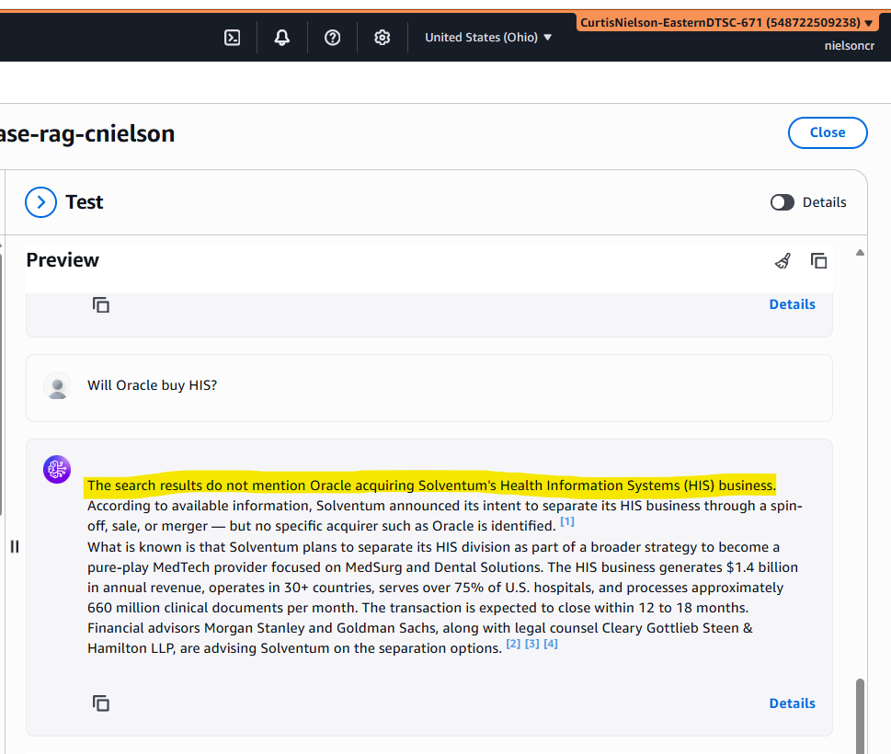

When I ask Gemini the same question, it offers an opinion based on information not included in the RAG dataset.

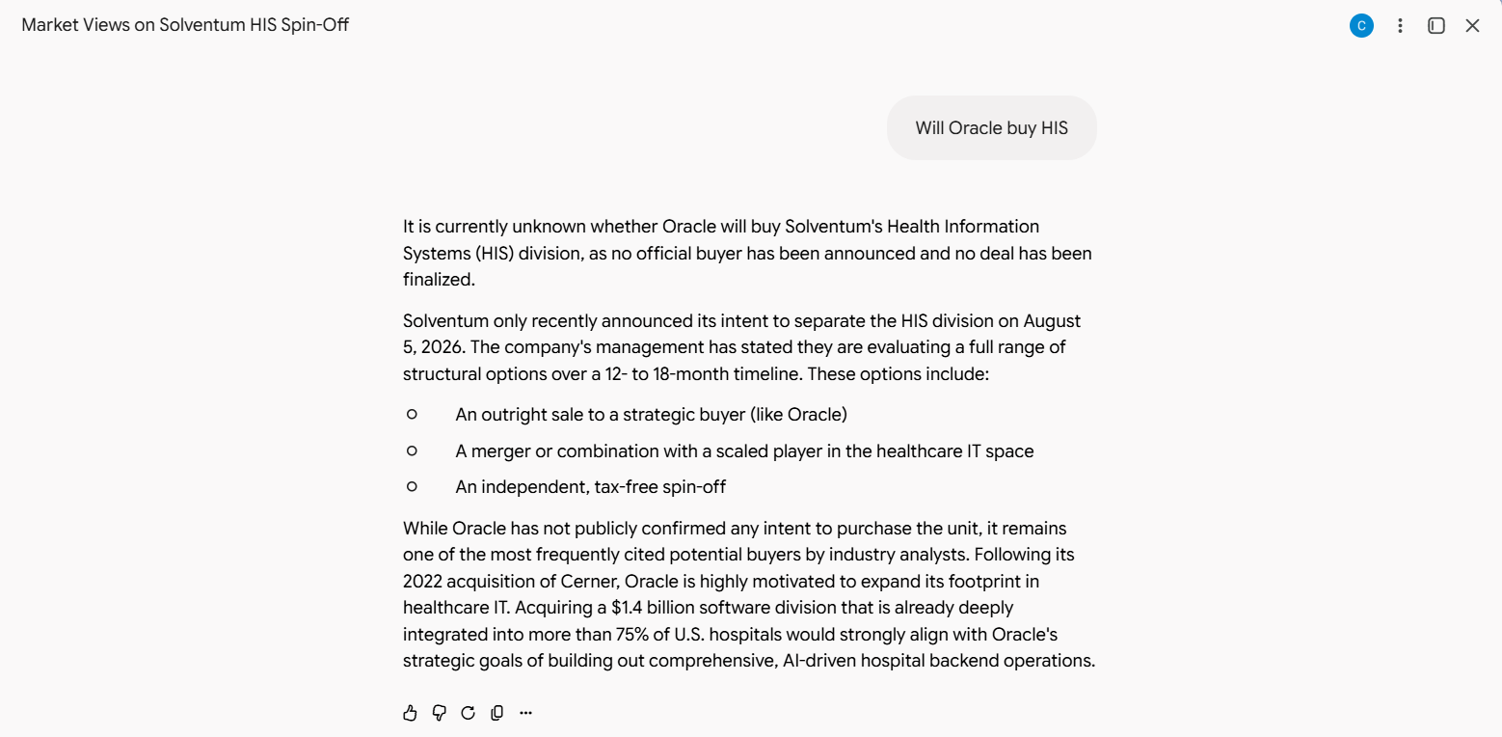

  - (10 pts) Screenshot of your RAG system test:
